Summer 2026

Dear For The Troops Supporter,

On Monday, September 21, 2026, For The Troops will host its 13th Annual Heroes' Golf Tournament at Moorpark Country Club, Moorpark, CA. As we do with all our fundraising events, the proceeds will go to sending ‘We Care’ packages to our deployed U.S. Military service members. Your support is greatly appreciated and needed.

We invite you to participate as a sponsor. We have several levels from Medal of Honor Sponsor to One Star Sponsor. This year, golfers will have a celebrity, actually a “Hero” playing with them. That "Hero" will be a golfer that is an Active Duty service member. For as little as $195, you can sponsor that Hero. Of course, we would love to have you come and play in the tournament as a Corporate or Co-Host sponsor. Bring business associates and/or your customers and make it a great day of camaraderie and networking. You may also choose to donate a live or silent auction item.

We look forward to having you with us as a Sponsor, a Golfer or Dinner attendee. Registration of your sponsorship may be done on our website, www.ForTheTroops.org. Please contact our golf tournament director, Jenna Venarde at Golf@ForTheTroops.org or (805) 217-0375 should you have any questions about a sponsorship or the event. Thank you so very much for your support of FTT and our U.S. Military men and women.

Very gratefully,

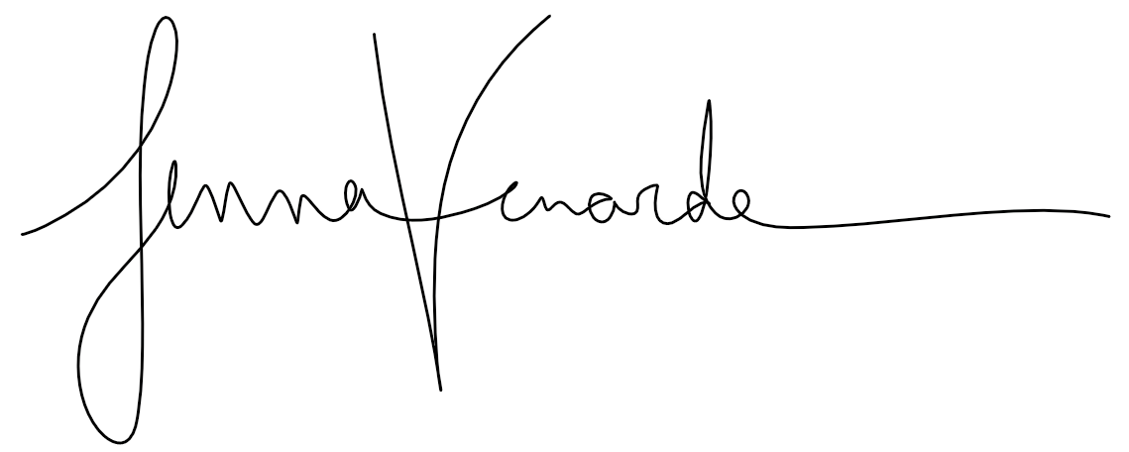

Jenna Venarde,
Golf Tournament Director


Paula Cornell,
President and Founder

